Particle tracking in Finite Different Method (Matlab implementation)

TO 070310

The flow (volumetric discharge), Q [L²T⁻¹], through a face in a rectangular finite difference network is given by
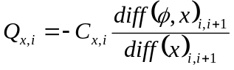
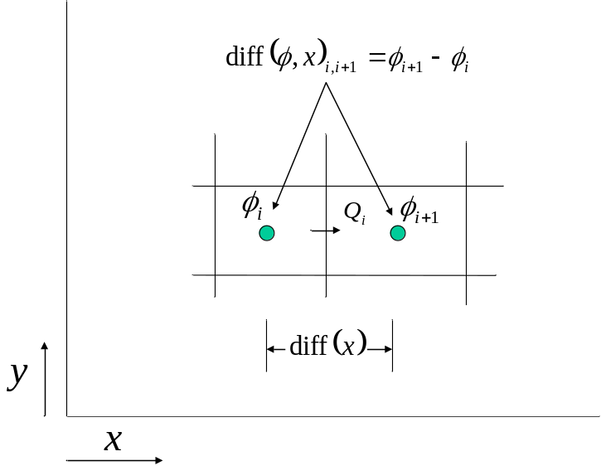
Figure 1: Head difference in a mesh-centered finite element network
where C_{x,i} is the so-called conductance [L²T⁻¹] between the two adjacent model cells in x-direction. “diff” stands for the difference operator, which equals the difference of adjacent values in a scalar parameter given in a 3D array (or 2D array in case of 2D flow).
The specific discharge is obtained by dividing by the area of the face:
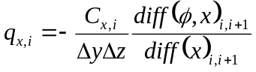 where i denotes the cell face in x-direction
likewise for the other two directions in a 3D network.
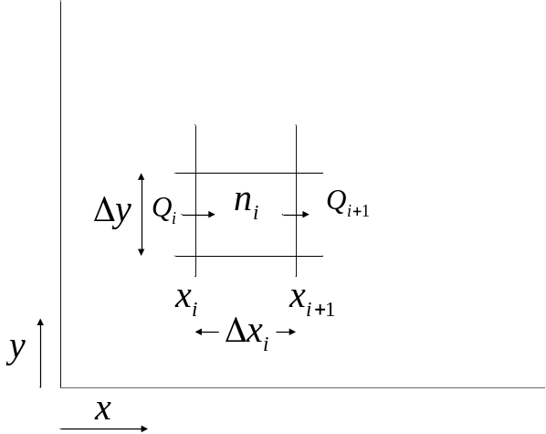
Figure 2: Coordinate axis with a model cell of a finite difference network
The specific discharge in any direction inside the cell is taken equal to the linear interpolation of the values of its two opposite faces:
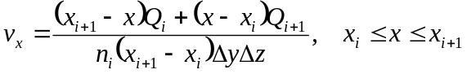, with cell porosity n_{i}.
Clearly,
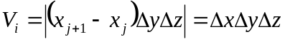 is the cell volume.
So that
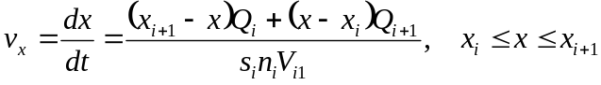
with 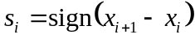 and 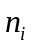 the porosity of the cell given by 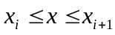 and

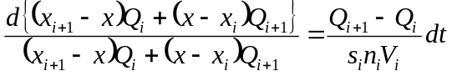

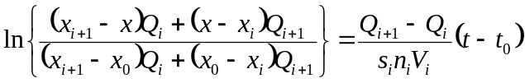 this yields the time at which a location is reached
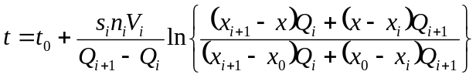

for this to work, 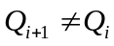 and 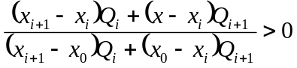
The numerator represents the velocity at x=x₀ and denominator that at x=x. If the denominator is zero, the particle will not leave its place. If the numerator is zero, the particle will never arrive because the velocity at the target position is zero. If the fraction is negative, it implies that the velocities at both position is opposite, in which case there must be a line of zero velocity in between. Then too, the particle will never arrive at the target position. In all cases, we may set the time to reach the target position at infinity unless we could provide information on the velocity inside the cell by the cause of the problem (extraction inside the cell or other causes).
In the case 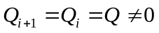 we have
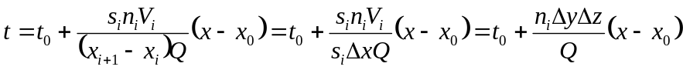
This expression still disintegrates in case 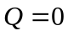, in which case we set 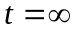.
In the other case, the velocity change is such that the particle will never reach the target coordinate.
A special case is when 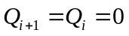, i.e. complete stagnation inside the cell.
A final special case exists if the particle starts in a point with zero velocity. It will never leave this location. A check to see if the velocity differs from zero is useful. The case where the velocity is constant in the cell needs a separate formula. The case where the opposite side of the cell will never be reached also needs consideration. This is the case when the discharge of opposite sides of the cell has different signs, which implies that there is a line of stagnation in the cell for at least one of the coordinates.
From the cell face discharges one cannot conclude the cause of the stagnation. It may well be an extraction or an infiltration. Without taking this into consideration, the particle will gradually slow down and come to a halt inside the cell after infinite time, when it reaches the stagnation line. In reality it might accelerate due to extractions in the cell. It is not clear yet how to take this acceleration into account in the particle tracking mechanism. A practical way may be to take arrival at the cell face as the true time of arrival for cells that have a net extraction.
We could compute the overall extraction of a cell and add the flow pattern due to a well in its center to the pattern given by the face flows.
So the discharge is divided into the part with no divergence and the part with full divergence and the two are superposed.
This will be too complicated for cases with non-square cells. Therefore the practical approach that MODFLOW uses will be applied here. If the extraction is more than a given fraction of the flow through the cell, it is considered an end cell and its walls are considered the location where the particles leave the model and their final travel time is determined.
In finite difference cells, a stagnation point may occur due to a recharge in which case
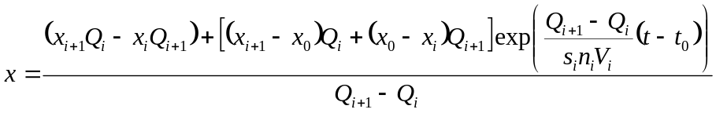
so for any time there is an x unless 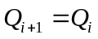
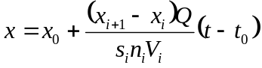
There is no objection to this expression in case Q=0.
(The sign must still be checked to see if it tackles all cases with axes that are in opposite directions compared with the order of points in the computer array representing the spatial field.
All that has been said works in all three dimensions. The three dimensions are dealt with separately, which largely simplifies the analysis.
So in all cells where the net extraction exceeds a certain fraction of the total flow through the cell, the cell walls are considered endpoints of the particles. To tackle starting particles, this is not the case if the flow is outward from the cell:
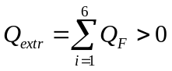 i.e. there is an net inflow into the 3D cell
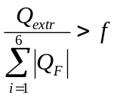 then the cell is an end cell and so are its walls for entering particles
, with 1,2,3 the dimension y,x,z in Matlab convention (the arrays must fit).

How to step through the network with time?
We know exactly the path of the particle inside each cell. To follow it’s actual path smoothly when plotting, we will divide the cell into a number of subcells. Another perhaps better and more general solution is to use the curvature of the path of the particle and limit the step size to a fraction of the radius of curvature.

